SOMERSET COUNTY AA ‘The Association’
RESPONSIBLE FOR ATHLETICS IN THE COUNTY OF SOMERSET
at www.somerset-athletics.co.uk

2026 MATCH U10/U12 SOMERSET AA V DORSET AA

SATURDAY SEPTEMBER 12th

Venue Bill Whistlecroft Athletics Arena, Yeovil, BA21 3DS
^{GENERAL INFORMATION}
^{TIMETABLE}
DIRECTIONS TO THE TRACK AND CAR PARKING
^{SAFETY AND FIRST AID}
TRACK EVENTS GENERAL INFORMATION
FIELD EVENTS GENERAL INFORMATION
^{PHOTOGRAPHY}
^{REFRESHMENTS AND CHANGING}
^{RELAYS}
^{BIB NUMBERS}
^{MEDALS AND CERTIFICATES}
^{RESULTS SERVICE}
^{DAKTRONIC TIMING DISPLAY}
^{PHOTOFINISH}
^{THE DEFINITIVE TIMETABLE}
^{APPENDIX 1 - FUNETICS}
^{FAQ}

The meeting is sponsored by England Athletics and, as a result, it is free of charge for selected athletes.
The meeting is hosted on the Roster platform
https://meets.rosterathletics.com/public/competitions/details/schedule?id=29259
Athletes will be uploaded onto the platform by the selectors. Athletes will NOT need to enter the competition themselves.
We (Somerset) plan to provide a plain T-shirt to wear on the day but athletes should also bring a plain T-shirt/club vest in case there is a problem with sizing.
The T-shirts can be kept by the athletes – they are free of charge
The timetable is already on Roster and is also shown below
Please refer to the FAQ section at the end of this file

U10 quadrathlon athletes should collect their T-shirt and vest number by 1:30 pm at the latest

U12 athletes, who contest individual events, should collect their T-shirt and vest number at least 30 minutes before their first event

We hope that, at some stage, you will be able to see the other athletes in the competition and their PB (where available) by clicking on the Roster link shown above

We expect that a parent or guardian will be present at the facility for the duration of the meeting

Timetable
https://meets.rosterathletics.com/public/competitions/details/schedule?id=29259

U10 | Time | U12
50m U10B and U10G | 14:00 | Javelin – Boys  Shot - Girls
Howler – U10G  Long Jump – U10B | 14:20
 | 14:30 | 600m – Boys and Girls
 | 14:50 | Javelin – Girls  Shot – Boys
Howler – U10B  Long Jump – U10G | 15:10
 | 15:20 | Long Jump – Boys  High Jump – Girls
400m – U10B and U10G | 16:00
 | 16:05 | Long Jump – Girls  High Jump – Boys
8 x 50m Non-scoring Relay – Boys and Girls | 16:20
Quadkids Presentation | 16:30
 | 16:50 | 75m – Boys and Girls
 | 17:10 | 4 x 100m Relay – Boys and Girls

U10 will contest a Quad competition (Funetics)
U10B 50m/Long Jump/Howler/400m
Then an 8x50m relay
U10G 50m/Howler/Long Jump/400m
Then an 8x50m relay

U12G and U12B will contest individual events
- Each athlete maximum three events plus a relay.
- Events:
Event | Maximum athletes per county per gender | Scoring athletes | Heats or Pools required
75m | 6 | 3 | 4
600m | 6 | 3 | 2
2k Shot | 6 | 3 | 2
Javelin | 6 | 3 | 2
Long Jump | 10 | 3 | 2
High Jump | 6 | 3 | 2
4 x 100m Relays | 3 teams | 1 team | 2
Field Events for U12s – three attempts in LJ, Shot, Javelin.
Track events – all straight finals
DIRECTIONS TO THE TRACK and CAR PARKING
Pickett Ln, Yeovil BA21 3DS
The track is now called the Bill Whistlecroft Athletics Arena (formerly the Yeovil Athletics Arena) which is situated between the Ilchester Road (A37) and the Mudford Road (A359) in Yeovil.

There is plenty of parking for cars and coaches off the Mudford Road (A359).
Take the Mudford Road, going out of Yeovil, from the large roundabout to the south of Yeovil College.
After 800 metres from this roundabout, take the road marked Chilton Grove on your left. The car park is 200 metres at the end of this road.
The track can be seen from the car park across the playing fields adjacent to the car park.
There is also parking for cars and minibuses only, nearer the track.
From the Ilchester Road- take the Marsh Lane/ Picketts Lane entrance.

SAFETY AND FIRST AID
The in-field area (inside the track) is out of bounds to all individuals except officials and athletes contesting events in that area. Athletes in this area should be vigilant and look out for the warning sign (usually a hooter) which indicates that an implement is about to be thrown.
Athletes crossing the track to access the infield also need to be vigilant in order to avoid athletes contesting track events.
First Aid, if needed, will be administered on site trackside. Otherwise, athletes should report to the First Aid area near the equipment storage areas.

THE TRACK and TRACK EVENTS
Competitors should report to the start area of the relevant event 10 minutes before the time listed in the programme. See the picture at the end of this document to remind you where the different starts are located.

The surface is an all-weather surface. If spiked running shoes are used (these are recommended but not essential), then the needles in the shoe must not exceed 6 mm. in length.

FIELD EVENTS

Field events athletes will have 3 trials.
In the U10 quadrathlon, if three no jumps / throws would be the result, the final attempt will be measured from position of foot at take-off / release of howler in order to ensure all athletes have a recorded performance.
In the individual events for the U12 age group, normal UKA rules will apply with regard to the ‘normal’ rules for the javelin and long jump

HIGH JUMP
Starting height and the mechanism of height progression

U12G/U12B
0.90 m
Subsequent heights will increase by an increment of 5 cms.

PHOTOGRAPHY
No photography is allowed in the in-field area, except for accredited photographers sanctioned by Somerset AA
Photography at all times should be ‘appropriate’.
Spectators should not take images of children (aged under 18 years), other than their own child/children, except as part of a group or activity shot.
The Association may allow accredited professional photographer(s) to take photos of athletes during the championship. These images may be posted on the internet but will not show any personal details of the athlete(s) concerned. In particular, the athletes will not be named.
With regard to athletes under the age of 18 and adult IPC athletes, parents/guardians/carers may request that these athletes are not included in any photos. In this case, please contact the meeting manager at somersetathletics@hotmail.co.uk before the championship commences.
The current UKA policy regarding photography can be viewed here - https://www.uka.org.uk/wp-content/uploads/2020/10/Photographic-Policy-Guidance-for-Athletics-Clubs-and-Stadiums-updated-2020.pdf
https://www.uka.org.uk/wp-content/uploads/2023/03/Photographic-Policy-Guidance-for-Athletics-Clubs-and-Venues.pdf
The event director David Cooke somersetathletics@hotmail.co.uk will give further guidance if required.

REFRESHMENTS AND CHANGING
Changing facilities and toilets are available in the clubhouse.
Refreshments for athletes/spectators will NOT be available from the YOAC clubhouse but they should be available from the pavilion next to the playing fields above (north of) the track.
There is some bad weather cover in the main stand but this may be closed off during the championship.
In the event of rain or strong winds, suitable clothing/protection is recommended.

RELAYS
See the prospectus above

BIB NUMBERS
Bib (vest) numbers will NOT be posted before the championship.
Numbers can be collected at the track on the day of the competition – from 1 p.m. in the YOAC clubhouse
Numbers must be worn front and back for all TRACK events.
For the jumping events, only one number is required.
Numbers should be pinned in the 4 corners.

Each athlete will have a unique number and this number is not shared with any other athlete in the championship.

MEDALS AND CERTIFICATES
All athletes will receive a medal

RESULTS SERVICE
The Roster software will show event results as soon as the event has been processed and finalised
A full set of results will also appear on the County website after the championship
We do not plan to display paper results on the day

DAKTRONICS TIMING DISPLAY
Weather permitting, we hope to use a large LED display.
As this timer is stopped by a photo-eye, and may be stopped by an athlete’s arm or head, the time displayed is only an approximation. However, the official photofinish time from the computer is unlikely to differ from this display time by more than 0.02s

PHOTOFINISH
It is very important that all athletes are reminded that they should not pass through the finish line except as competitors.
Similarly, athletes who have completed an event should NOT pass backwards through the line and should move away from the finish line in a forward direction.
Spectators should never cross the track or be on the track near the finish line.

David Cooke
Championship Secretary
25/08/2026

APPENDIX 1
FUNETICS GUIDANCE NOTES

For parents and competitors

I appreciate that many parents will be unfamiliar with track and field athletics
Funetics (FMC = Funetics Multi Challenge) is an England Athletics initiative designed to introduce young children into the sport
It comprises 4 events – the plan is to go quickly from one event to another and complete everything in 2 hours

Running shoes and clothing
Any sort of trainer/running shoe will be fine
If the athlete wishes to wear shoes with spikes, then that is OK but the ‘needles/spikes’ in the shoes must be less than 6mm long
T-shirt and shorts are the usual clothing for this sort of event. Make sure that the athletes have warm clothing to wear between events. It can be cold and wet in September.

Vest numbers (also called bib numbers)
All athletes will wear card numbers front and back on their vest/T-shirts. The numbers are best secured with safety pins in each corner. Please bring pins if you have them.
Numbers are collected from the Yeovil Olympiads clubhouse – see the picture of the track at the end of this appendix to see location of the clubhouse.

Spectators
The infield area (inside the track) should only be accessed by athletes and officials
Spectators are NOT allowed in this area
Parents must watch the long jump and the javelin from outside the track

Events for U10 athletes aged 8 years and 9 years (this is the child’s age on the 31st August, 2026)
1. 50 metres – this is run in lanes on a straight section of the track near the stadium.
The starter will say ‘on your marks’ and then says ‘set’
After that the starting ‘gun’ will fire and the race starts
The finish line is at the end of this home straight (see picture at the end of the appendix)
Runners should not go back across the finishline after finishing the race

- 400 metres
This starts at the end of the home straight and finishes at the same place – in other words, one lap of the track (see picture at the end of the appendix)
The starter will say ‘on your marks’ and then the starting ‘gun’ will fire and the race starts
The runners will line up along the curved line that is marked on the track
Runners should NOT go back across the finishline after finishing the race

- Turbo Javelin (Howler)
Athletes in clubs might already be familiar with this javelin. If not, it looks like this-
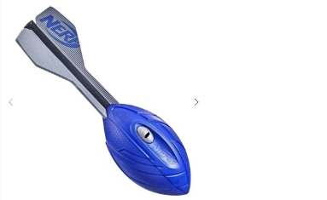
Athletes will have 3 throws – if an athlete has three ‘no throws’ then position of the foot at the release of the howler will be used to measure the distance thrown. This will ensure that all athletes have a recorded performance.

- Long jump
If an athlete has three ‘no jumps’ then the position of the foot on the third jump (at take-off) will be used to measure the distance
We guarantee that at least one jump will be measured.

Events for U12 athletes aged 10 years and 11 years (this is the child’s age on the 31st August, 2026)

- 75 metres
See instructions for the 50m race as shown above
- 600 metres
See instructions for the 400m race as shown above, except the start is at the half way point on the track
- Long Jump
UKA rules apply in this age group – namely three jumps, at least one of which needs to be a valid jump. Otherwise the athlete will score no points in this event.
- Javelin
A conventional 400g javelin will be used (not a Howler)
- Shot Putt
Both age groups will throw the 2kg implement
- High jump
See the information given earlier in the document

TRACK LAYOUT showing location of start locations/finishline/clubhouse

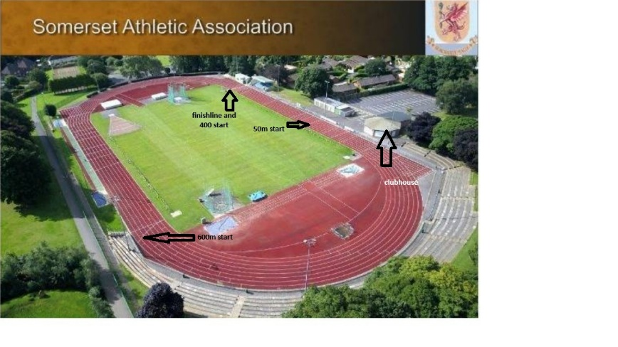
FAQ
- In the U10 multi-event competition (Funetics), do I have to do all 4 events?
Answer – we expect all athletes to compete in all 4 events unless they are injured or unwell. The more points that we (Somerset) score, the better we will perform in the Inter-County competition

- Do I have to enter the competition using the Roster online website?
Answer- No, the meeting organisers will enter every athlete onto Roster. You will be able to see the start lists when the organisers start to populate the website with names
See this link for updates-
https://meets.rosterathletics.com/public/competitions/details/schedule?id=29259

- How much will it cost?
Answer – the meeting is free of charge for selected athletes. The meeting is sponsored by England Athletics

- What shoes can I wear?
Answer- any sort of training/running shoes are suitable. We do not expect the U10 to have spiked shoes

- Where do I collect my number?
Answer – see the Funetics guidance notes in the section above

- Why is August 31st the date used to calculate most age groups?
Answer – if the competition used the age on the day of that particular meeting to determine the age group then many athletes would change age group in mid-season. This is clearly not desirable.
As a result, some U10 athletes might already be aged 10 years old on September 12th and some U12 athletes might already be aged 12 years old. This is not a problem.
Your age group is your age on 31/08/2026

