HOW TO ADD CLUBS TO YOUR ROSTER PROFILE
Sign in and open ‘Account’
The screen below should appear - Click on ‘Athletes and Relays’
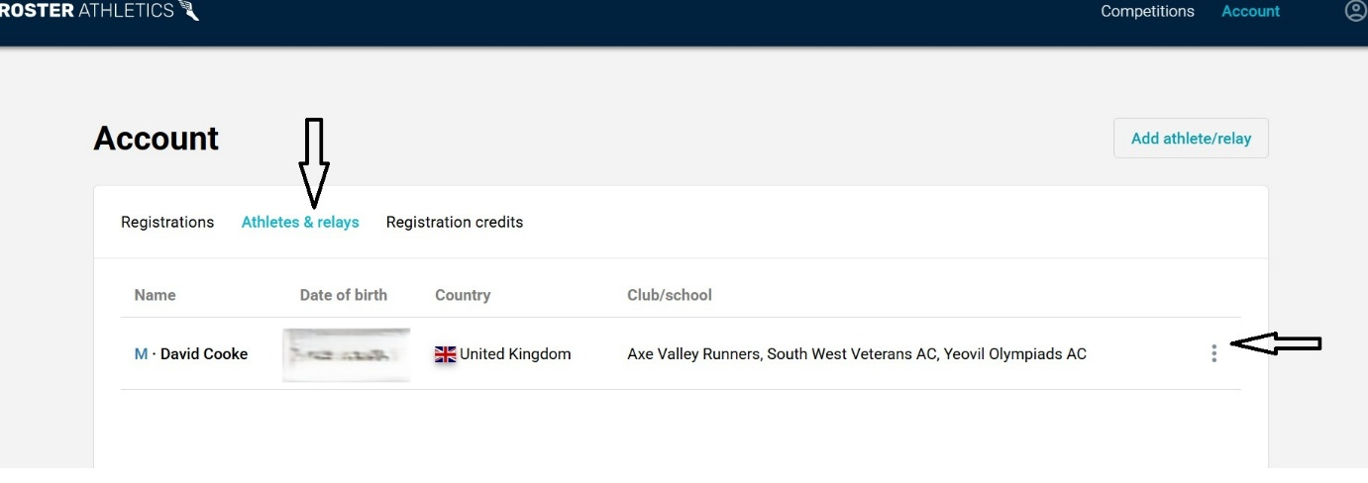
On the image above, click on the three dots on the right
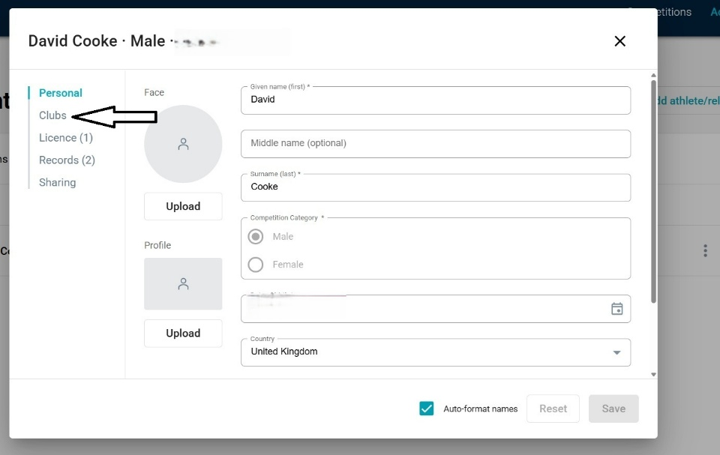
Click on ‘Clubs’
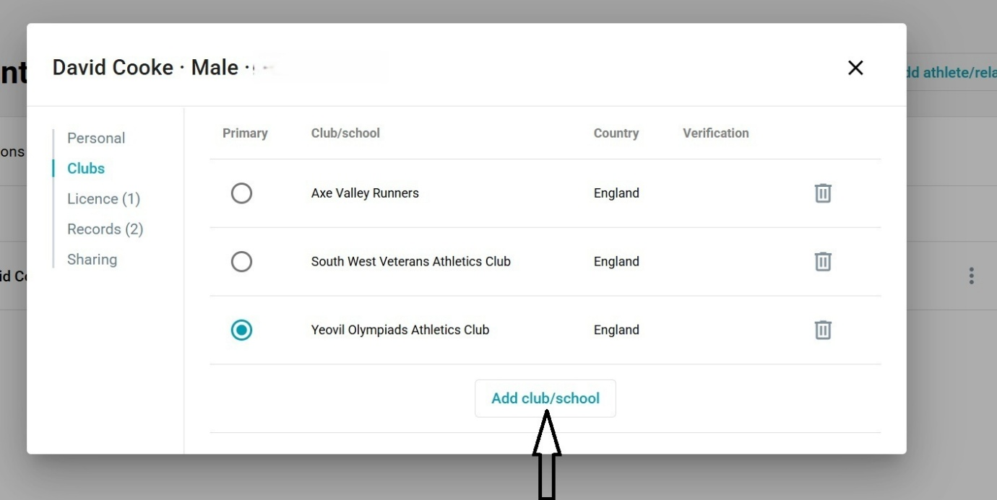

Click on ‘Add club/school’
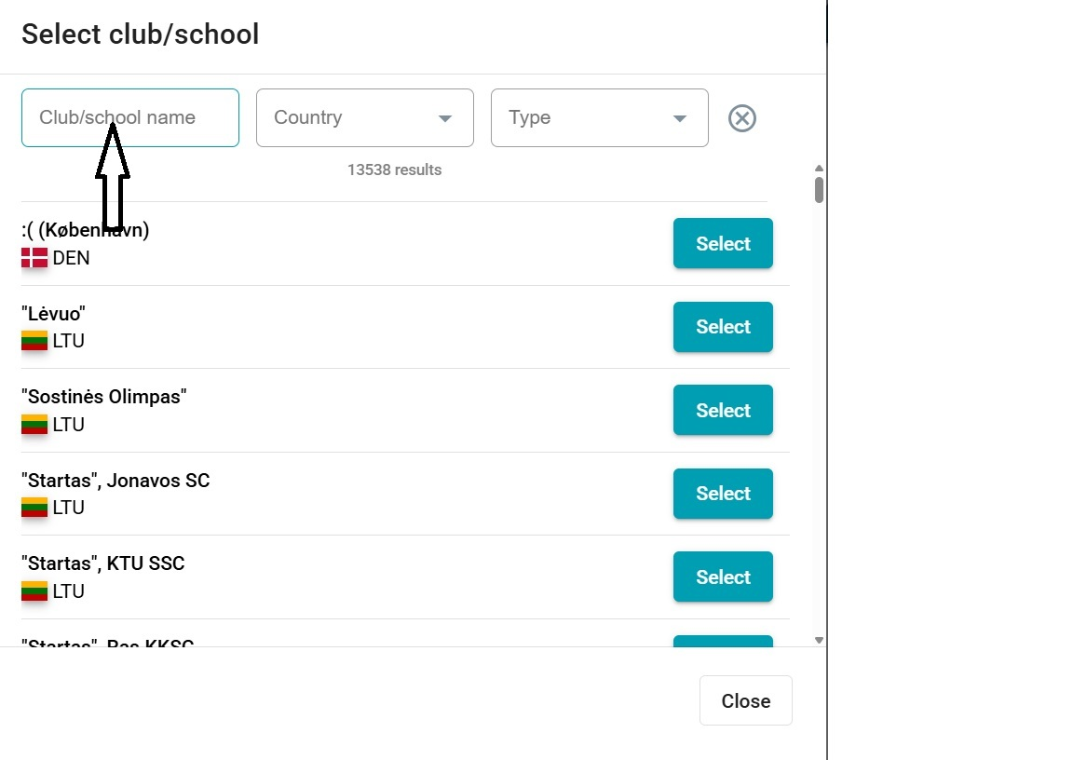
In the box arrowed in the picture above, write in the name of the club you want to add

