Go to the main Roster website
https://meets.rosterathletics.com/public/competitions
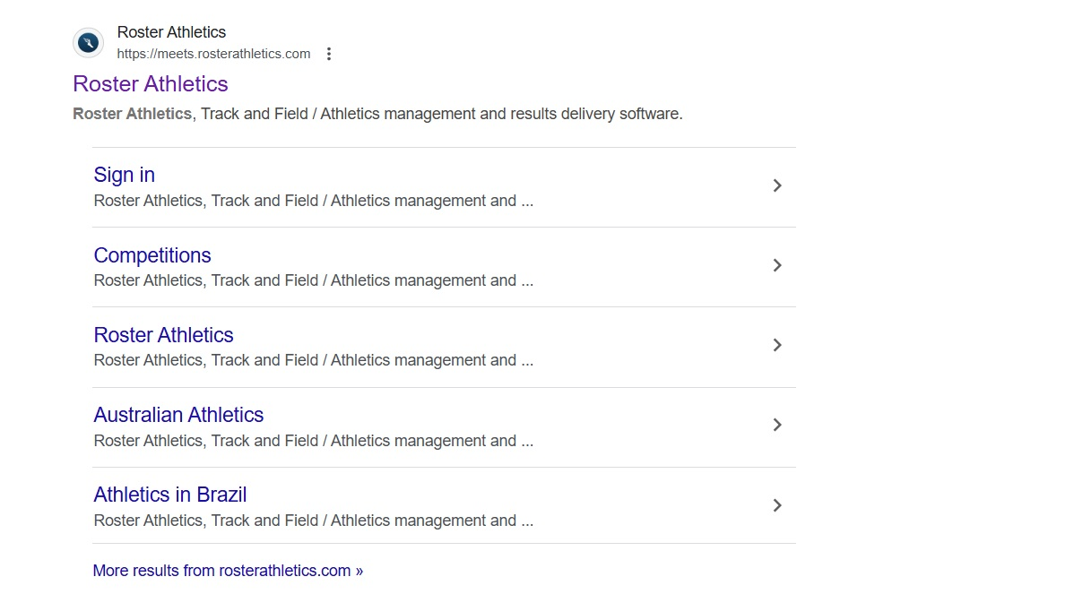
Click on the heading ‘Roster Athletics’ – not the Sign In link
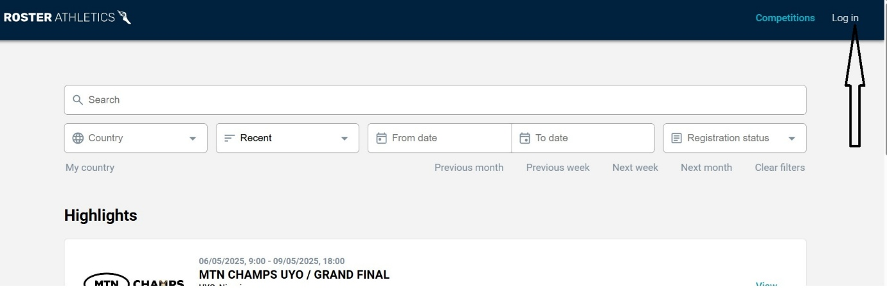
Click on Log In (as shown above)
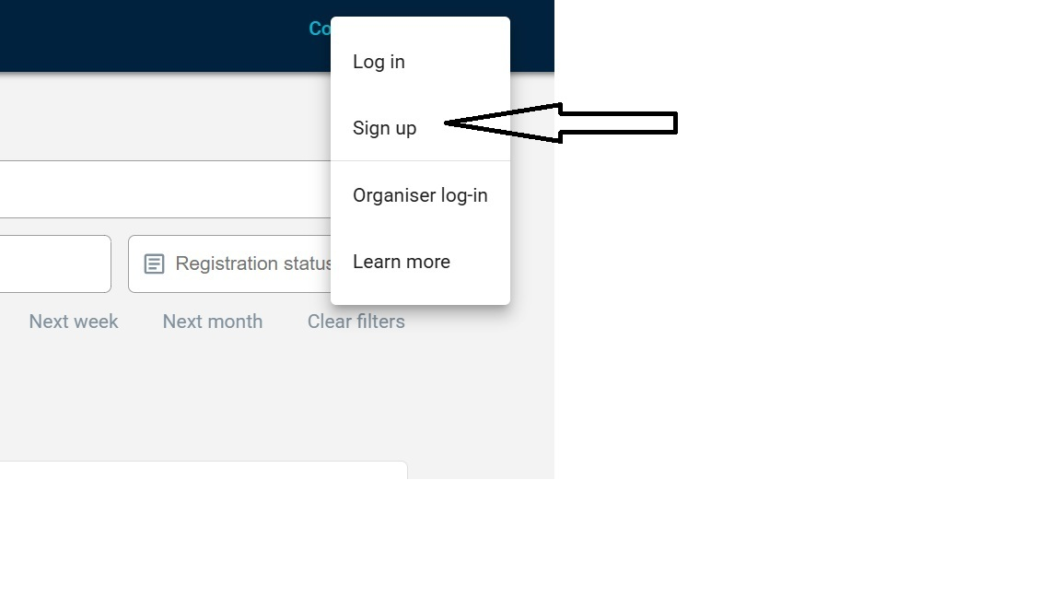
Click on ‘Sign up’
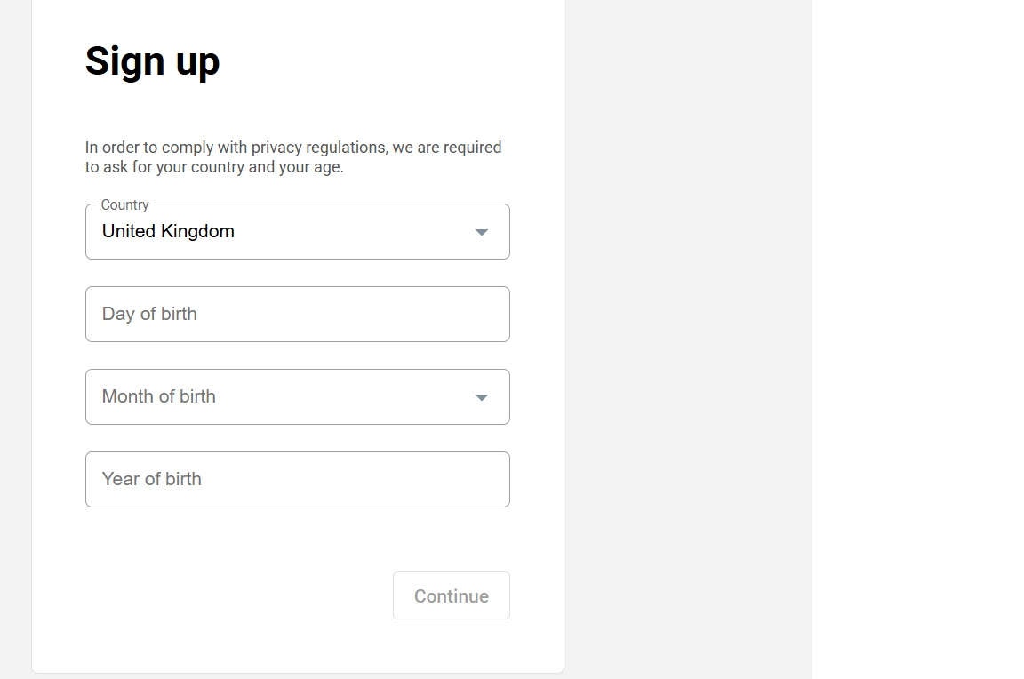
Fill in the detail as requested and then click ‘Continue’
Simply follow the subsequent instructions

David Cooke 8/5/2025

